Illume Student Advisory Services
ERP — Staff User Guide
Signing in, setting up two-factor authentication,
and using the ERP day to day
Document | Standard Operating Procedure
Audience | All Illume staff with an ERP account
Applies to | illumestudentservices.cloud
Version | 1.1
Issued | 9 October 2026

About the screenshots in this guide
Every screen shown here was captured from the live application using a demonstration account, which was deleted afterwards. No colleague's personal details, leave record or tasks appear anywhere in this document. Where a screen showed a security code, that part of the image has been blurred on purpose.

1. Before you start
You will need two things. Please have them both to hand before you begin, because setting up your account cannot be paused halfway through.
- The welcome email. Sent to your work address as soon as HR creates your record. It carries the link you use to set your own password, and that link stops working after 72 hours.
- A smartphone. You will install a free authenticator app on it. Any phone will do.
Nobody sends you a password
There is no temporary password, and IT cannot tell you yours. You create it yourself from the link in the welcome email, and from that moment only you know it. Anyone who contacts you offering your password, or asking for it, is not from Illume.

The ERP works in any modern browser — Chrome, Edge, Firefox or Safari. You do not need to install anything on your computer.

Which authenticator app?
Any of these work. If your phone already has one, use that one.
- Microsoft Authenticator
- Google Authenticator
- Any other app that supports TOTP codes
If you do not want to install an app
There is a second option: the system can email your code to you instead. It is offered on the setup screen as “Email my codes instead”. Please use the app if you can. Email is less secure, because anyone who reaches your mailbox could also reset your password — both of your security factors would then be in the same place.

2. Setting your password
Your account starts with no password you can use. The welcome email gives you a one-time link to create one.

Step 1 — Find the welcome email
The subject line is “Welcome to Illume — set your password”. It lists your employee ID, job title and the email address your account uses. Check that the email address shown is the one you expect, because that address is your username from here on.
The link expires in 72 hours
If more than three days have passed, the link will no longer work. Do not worry — open the sign-in page, choose “Forgot password”, and a fresh link will be emailed to you. You can also ask HR to send the welcome email again.

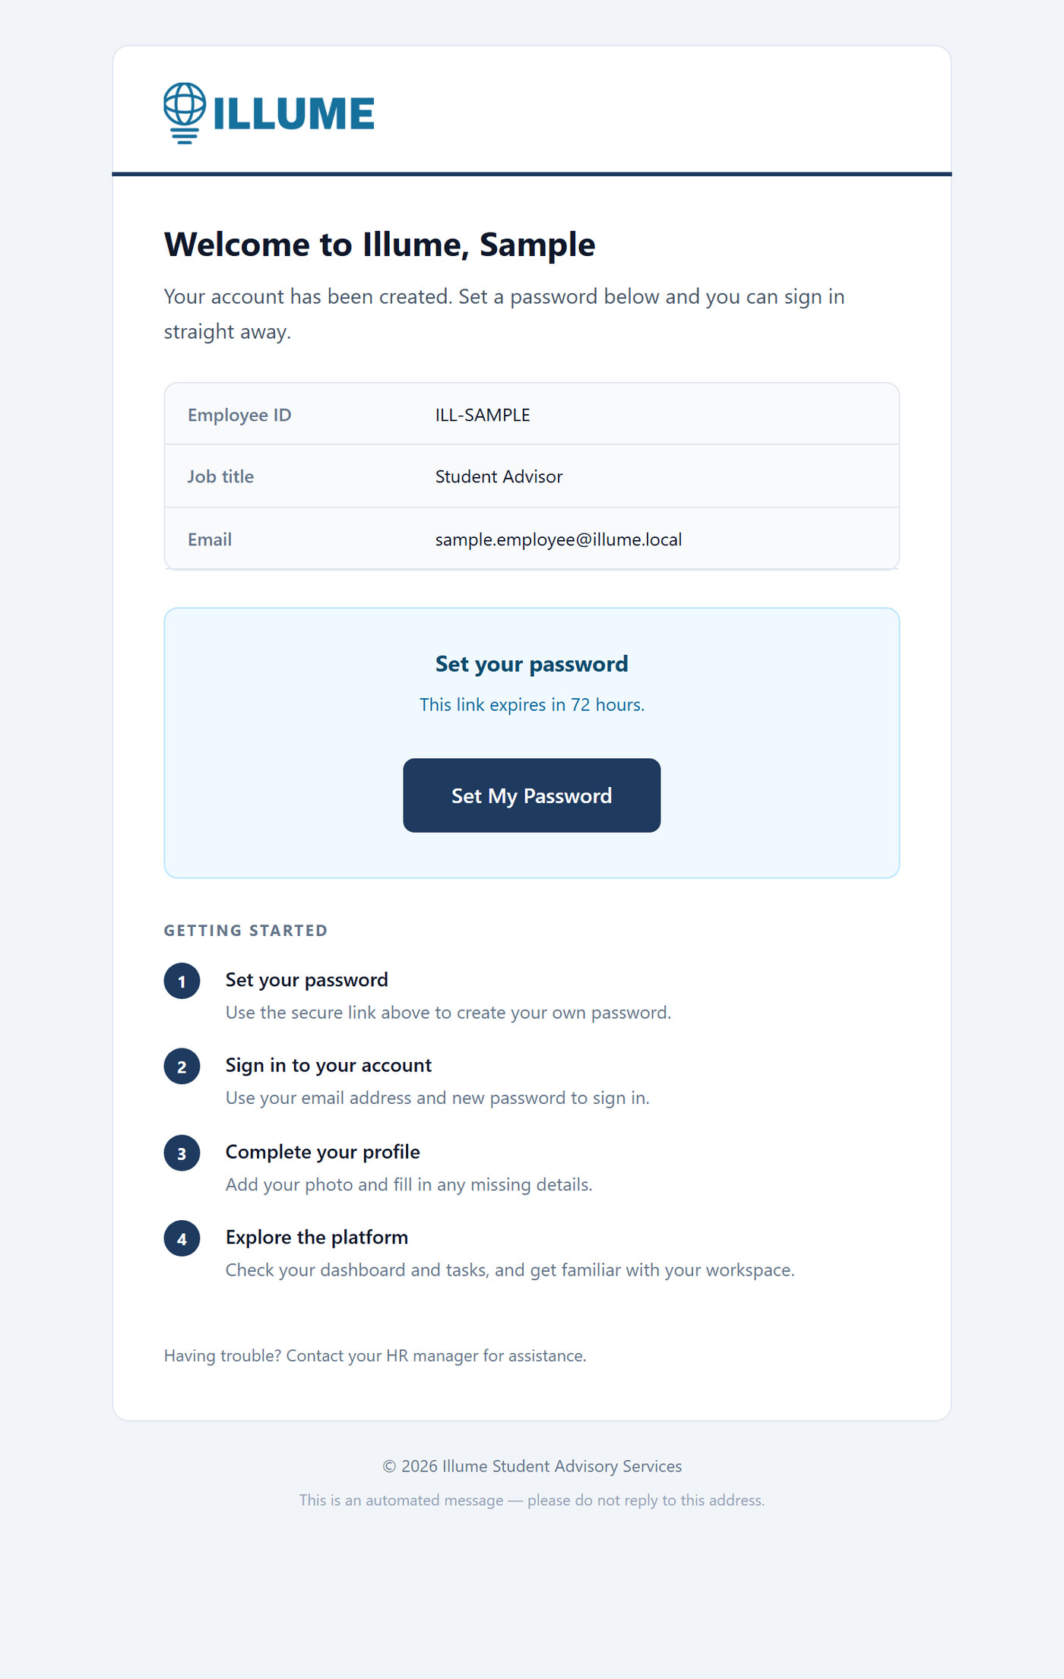
Figure 1 — The welcome email. Select Set My Password.

Step 2 — Create your password
The link opens the Set Your Password screen. Type the password you want to use, then type it again to confirm.
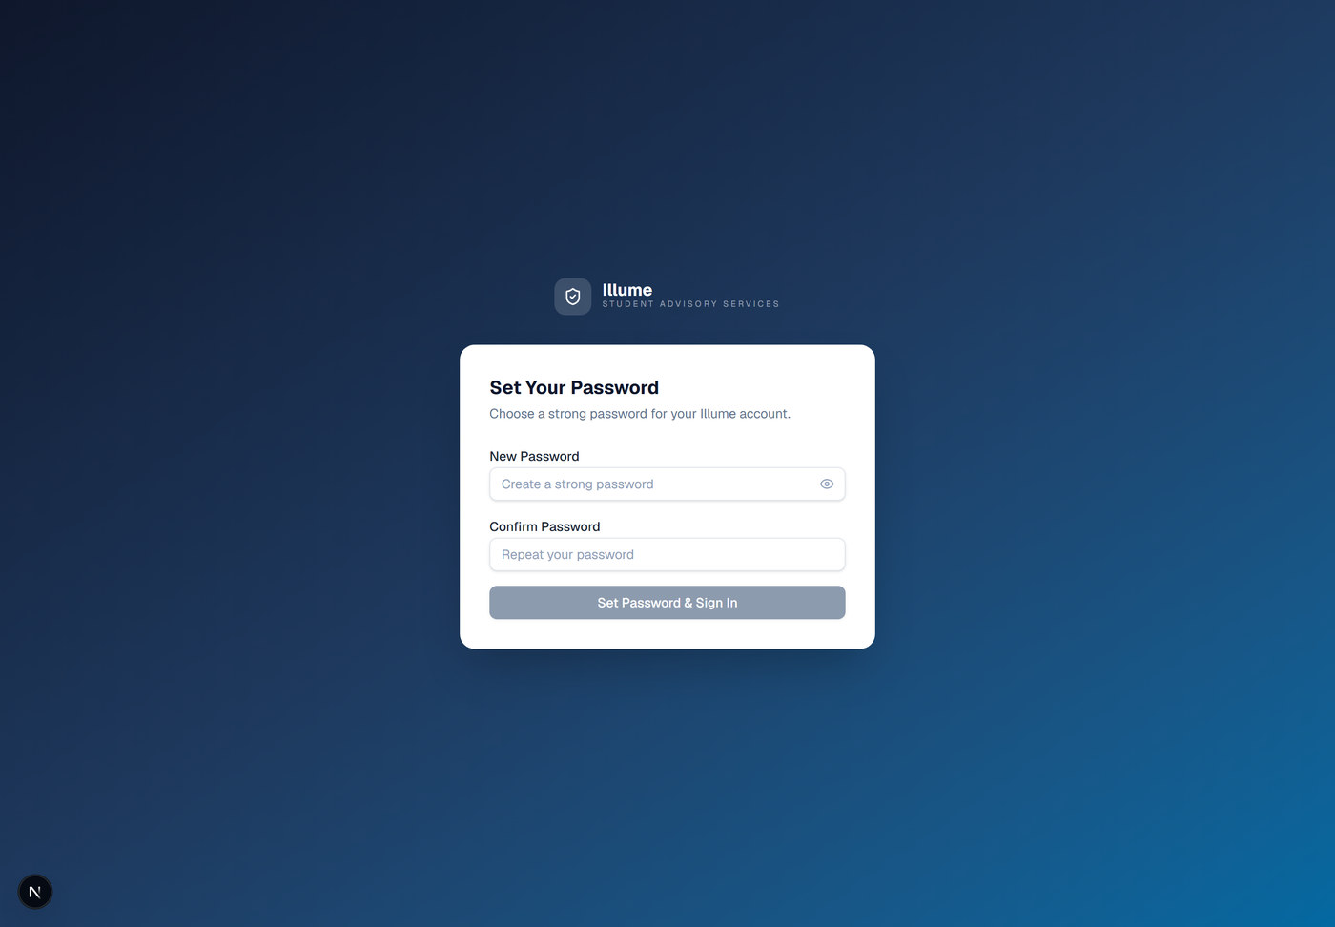
Figure 2 — The Set Your Password screen.

Choosing a good password
- Long beats complicated. Three or four unrelated words are both stronger and easier to remember than one word with symbols substituted into it.
- Do not reuse a password you use anywhere else, and never reuse one you have used on this account before — the system will refuse it.
- A password manager is the easiest way to keep it safe. Write it down on paper if you must, but not on a note stuck to your screen.
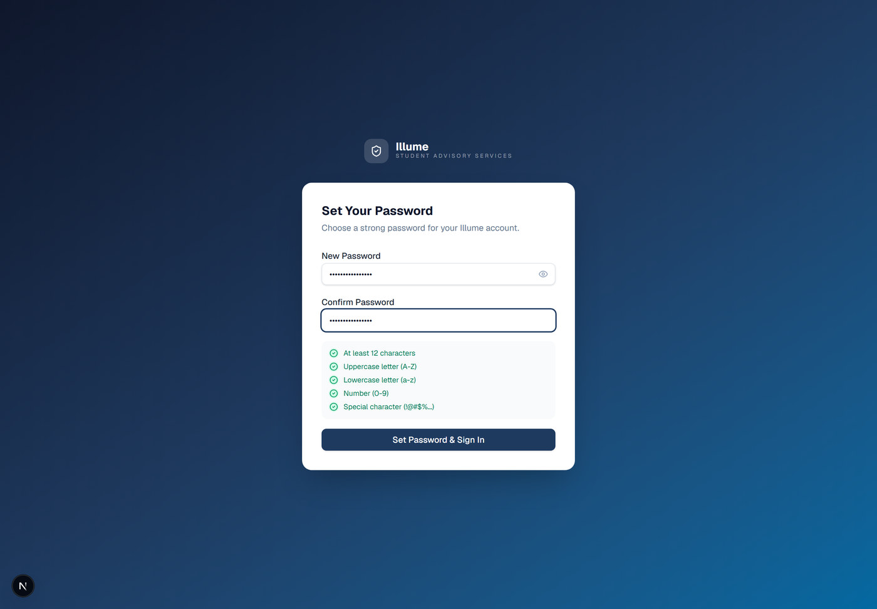
Figure 3 — Both boxes filled in. Select Set Password & Sign In.

Step 3 — You are sent to the sign-in page
You will see a short confirmation and then be taken to the sign-in page. The button is labelled Set Password & Sign In, but you do still have to sign in yourself on the next screen — that is expected.
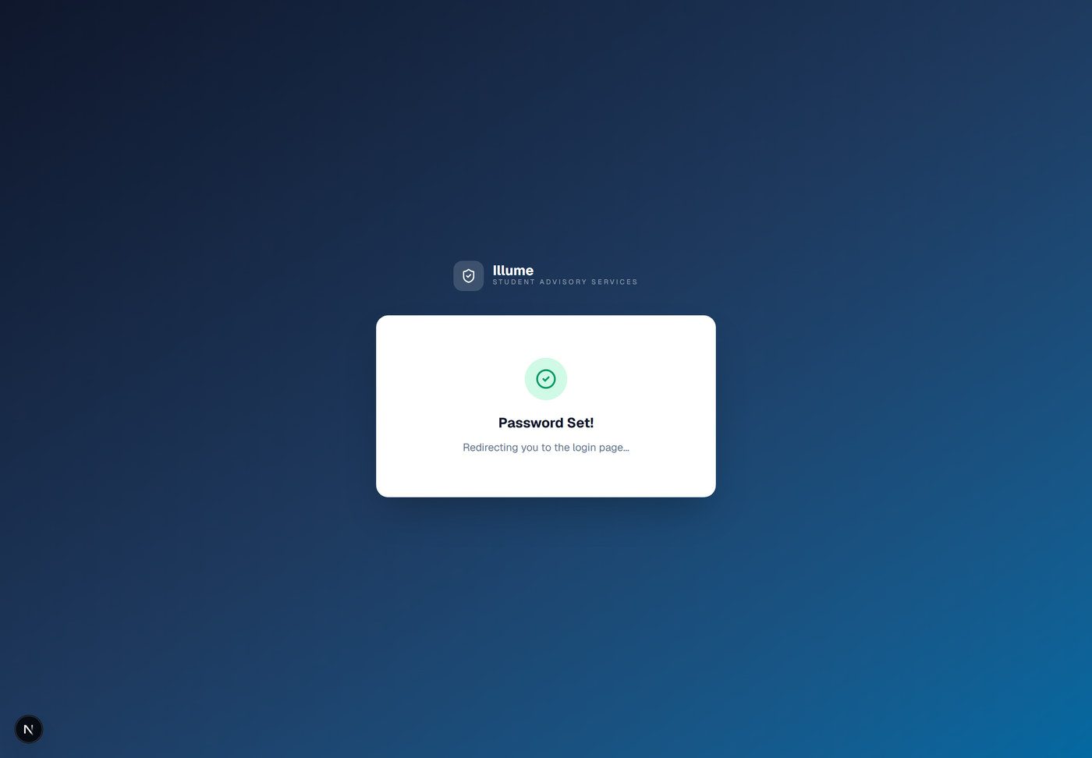
Figure 4 — Your password is set.

3. Signing in for the first time
This section is only needed once. After it is done, signing in takes a few seconds.

Step 1 — Open the sign-in page
Go to illumestudentservices.cloud. You will see the sign-in screen.
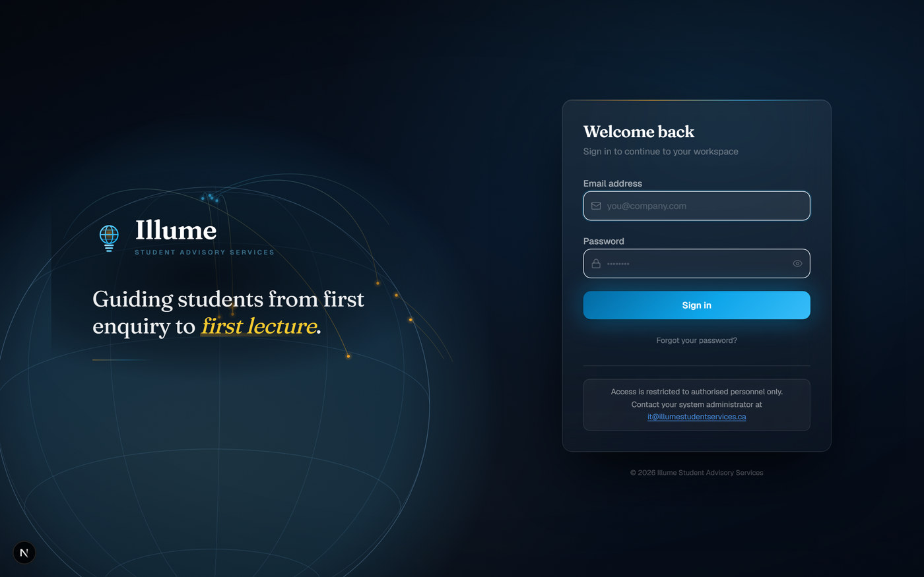
Figure 5 — The sign-in screen.

Step 2 — Enter your email and password
Type your work email address and the password you created in section 2, then select Sign In.
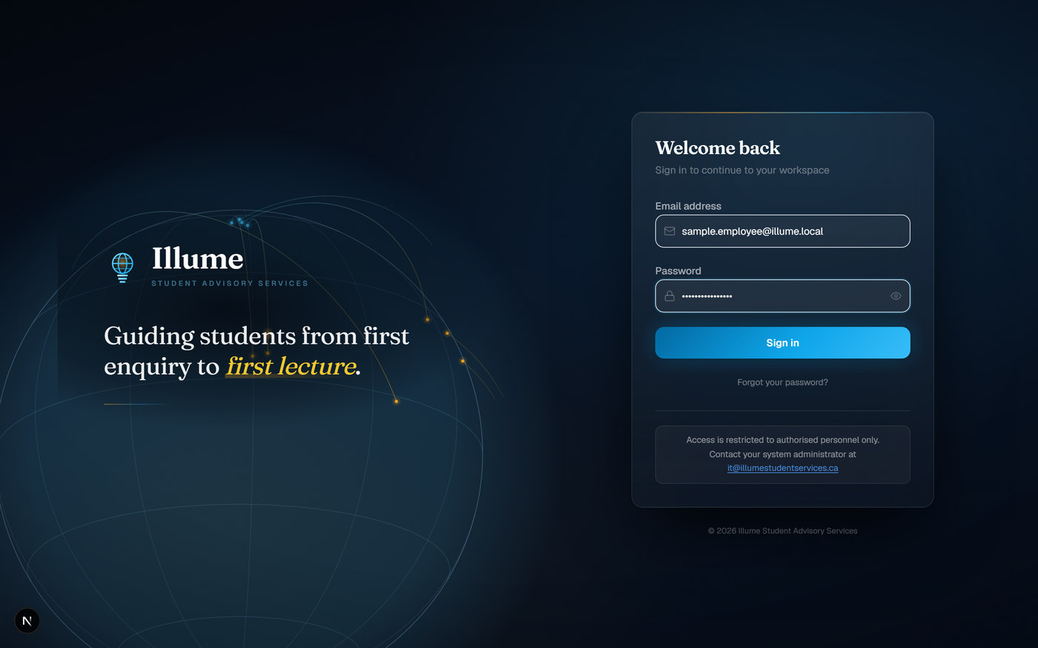
Figure 6 — Email address and password entered.

Step 3 — Begin two-factor setup
Because this is your first sign-in, the system asks you to set up two-factor authentication before it lets you any further. This is required for every account, without exception. Select Begin setup.
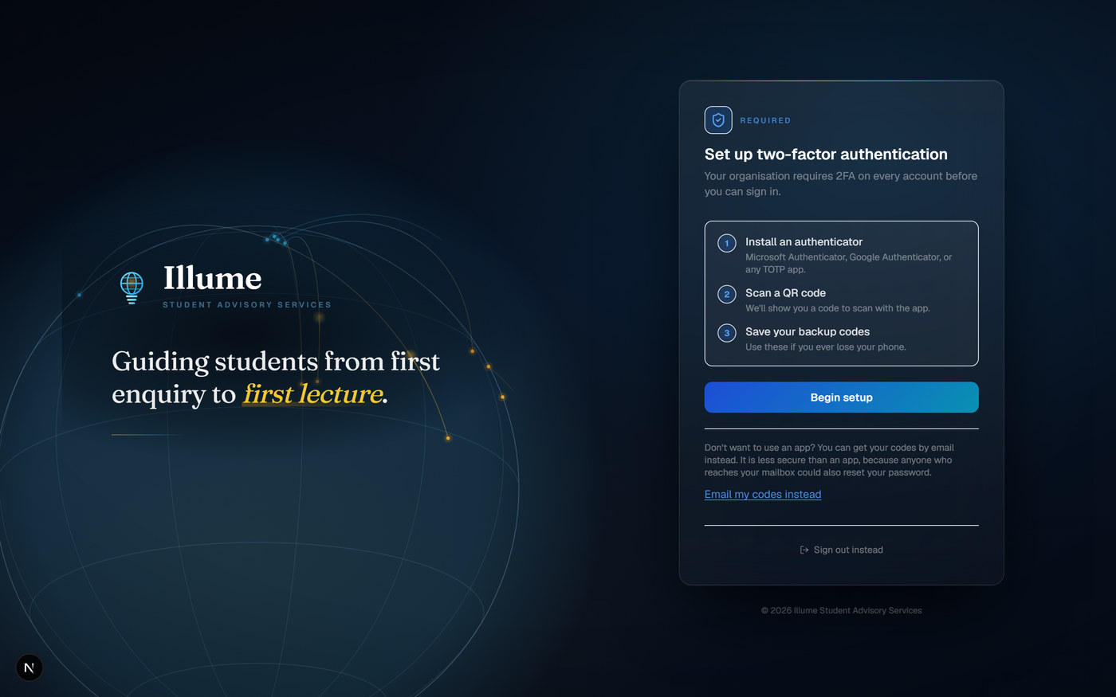
Figure 7 — The two-factor setup screen, shown at first sign-in.

Step 4 — Scan the QR code
A QR code appears. Open your authenticator app, choose to add an account, and scan the code with your phone's camera. The app will then start showing a 6-digit number for Illume CRM that changes every 30 seconds.
The QR code is blurred in this guide on purpose
The code shown on your screen is unique to you. It is the key to your account. Never photograph it for anyone else, never email it, and never put it in a shared document.

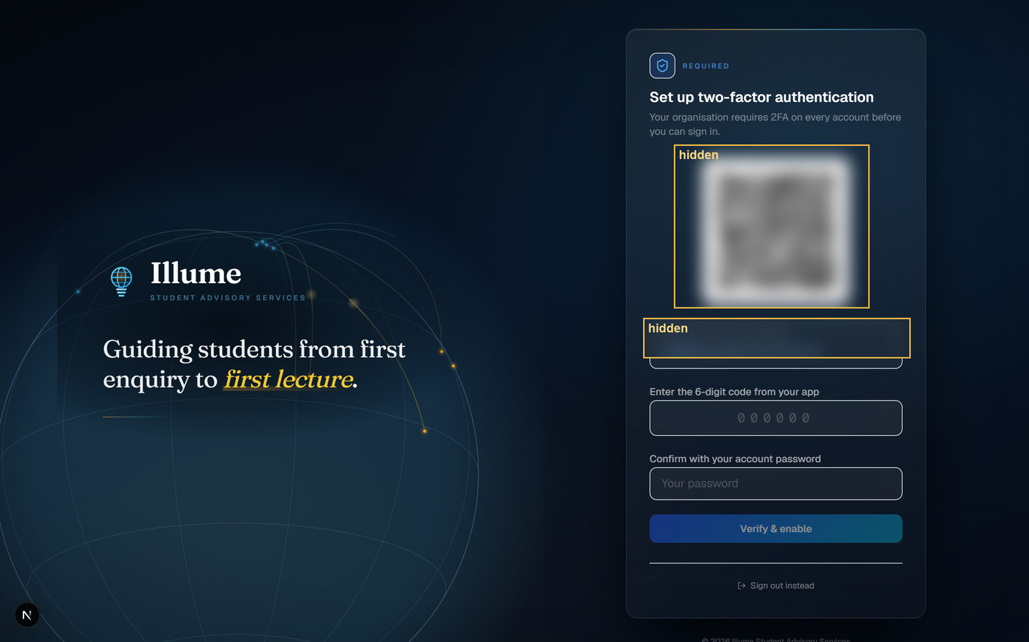
Figure 8 — The QR code screen. Scan the code with your authenticator app.

Step 5 — Enter the code and confirm with your password
Type the 6-digit number from your app into the box. You will also be asked for your account password a second time. This is deliberate — it proves it is really you turning on two-factor authentication. Then select Verify & enable.
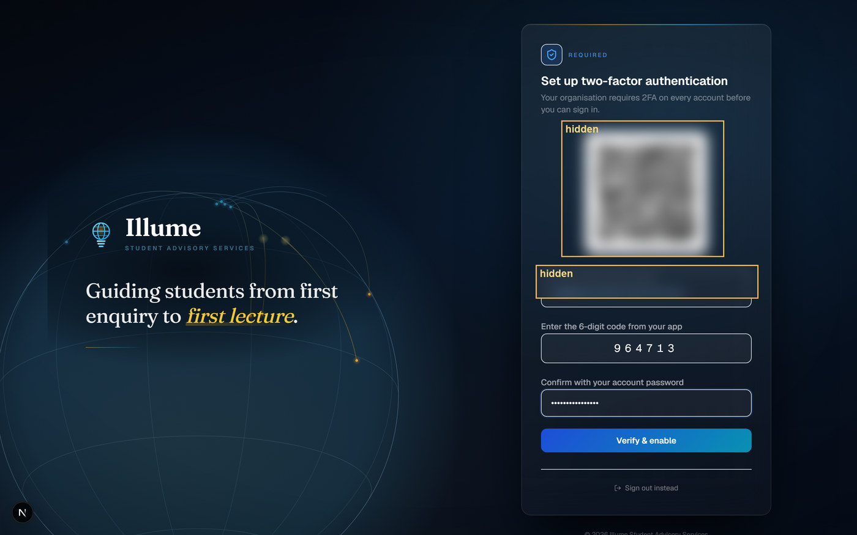
Figure 9 — The 6-digit code and your password, ready to confirm.

Step 6 — Save your backup codes
Two-factor authentication is now active, and the system shows you eight backup codes. These let you sign in if you ever lose your phone. Each one works once, and they are never shown again.
Save these somewhere safe, now
Put them in a password manager, or print them and keep them somewhere secure at home. Do not save them in your email, in a note on the phone that holds your authenticator app, or in a shared folder. If you lose both your phone and these codes, IT has to reset your account for you.

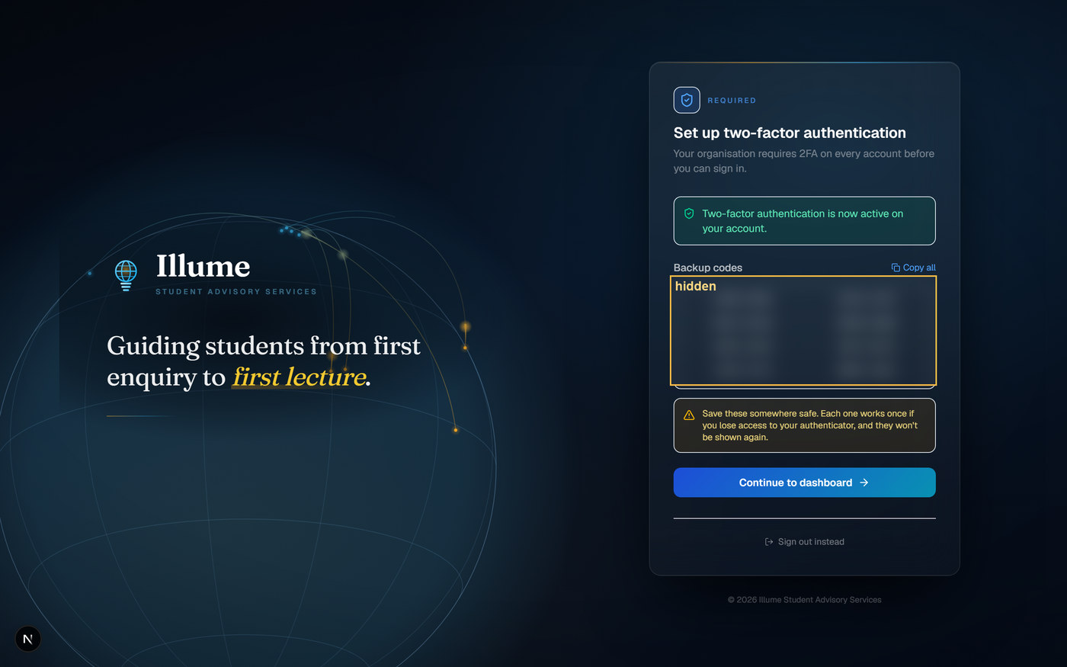
Figure 10 — The backup codes screen. The codes are blurred here — yours will be visible.

Step 7 — Sign in again
Setting up two-factor authentication does not sign you in. You will be asked to sign in once more, and this time the system asks for a code from your app. This is normal and only happens on this first occasion.
From now on, signing in is: email, password, then the 6-digit code from your app.
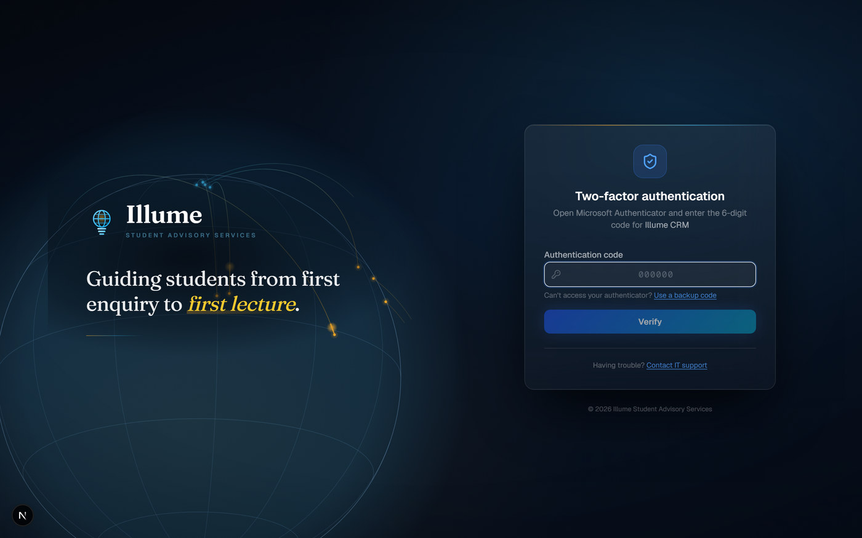
Figure 11 — The code prompt you will see at every sign-in from now on.
Every time you sign in from now on
Email → password → 6-digit code from your app. If the code is refused, wait for the app to show a new one and try again. Codes expire after 30 seconds.

4. Finding your way around
Once signed in you land on your dashboard. The menu on the left is how you move around the system.
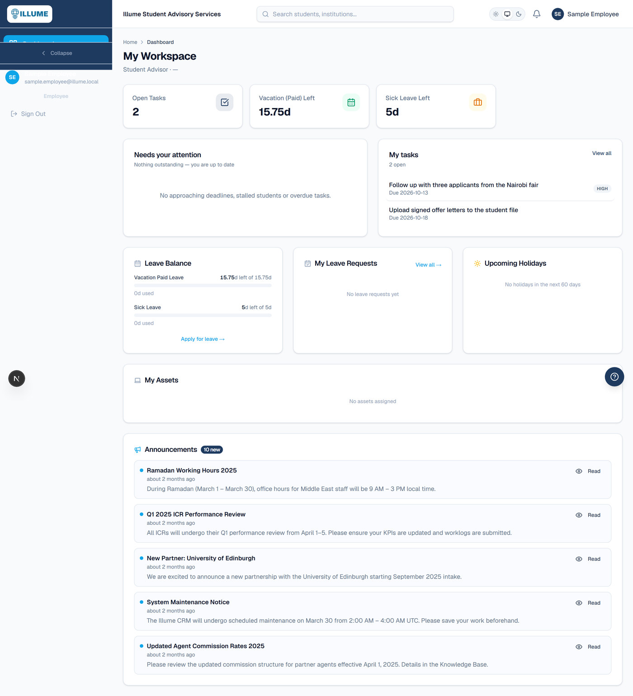
Figure 12 — The dashboard. Your menu is on the left.

What each menu item is for
Menu item | What you use it for
Dashboard | Your summary: leave remaining, open tasks, and anything waiting on you.
Tasks | Work assigned to you, and work you have assigned to the people who report to you.
HR & ERP | Your own staff record: leave, public holidays, documents, assets and training.
Knowledge Base | Guides and reference material shared across the company.

If you do not see a menu item mentioned elsewhere in the company, that is normal. People only see the parts of the system their role needs.

5. Your staff record
Select HR & ERP in the menu. You are taken straight to your own record. The tabs across the middle hold the different parts of it.
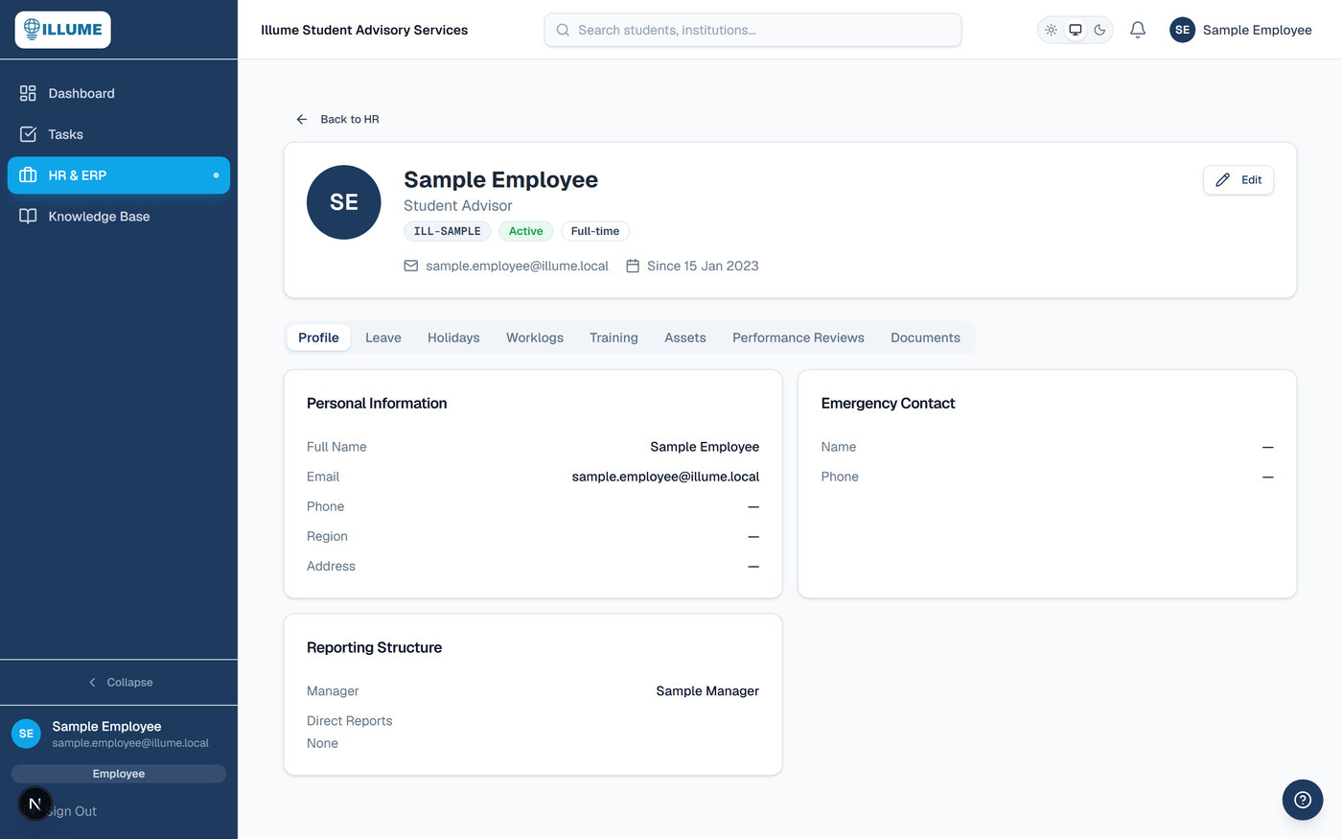
Figure 13 — Your own staff record, opened at the Profile tab.
- Profile — your job title, start date and contact details.
- Leave — how much leave you have left, and your leave history.
- Holidays — the public holidays that apply to you.
- Worklogs — time recorded against your work.
- Training — training assigned to or completed by you.
- Assets — company equipment issued to you.
- Performance Reviews — your review records.
- Documents — documents HR holds for you, such as your contract.

5.1 Checking your leave balance
Open the Leave tab. Your entitlement is shown at the top, with how much you have used and how much is left. Your leave history is underneath.
Your entitlement is worked out from your joining date, so it increases through the year rather than appearing all at once in January.
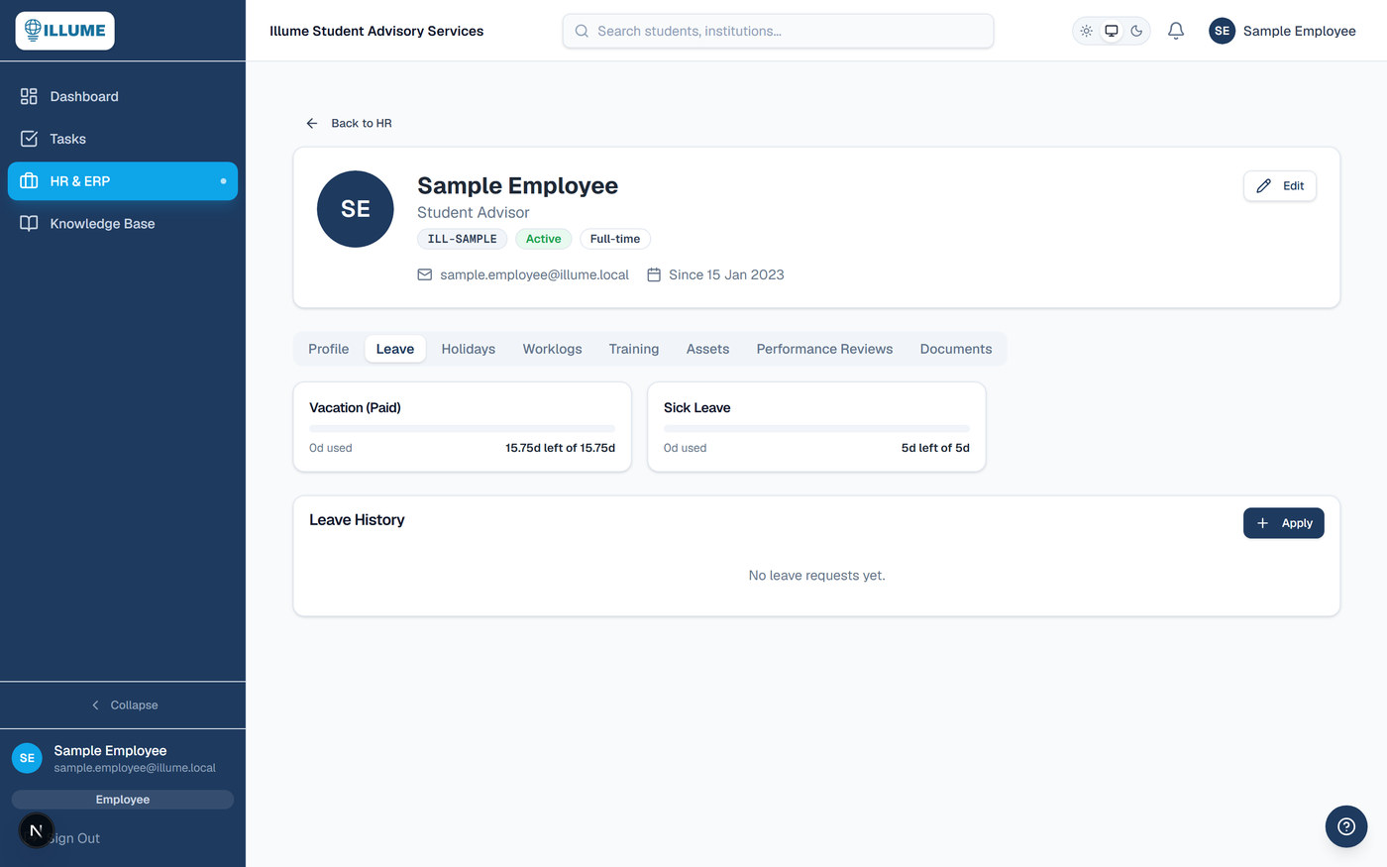
Figure 14 — The Leave tab: your balances at the top, your history below.

5.2 Applying for leave
Select Apply on the right of the Leave History panel.
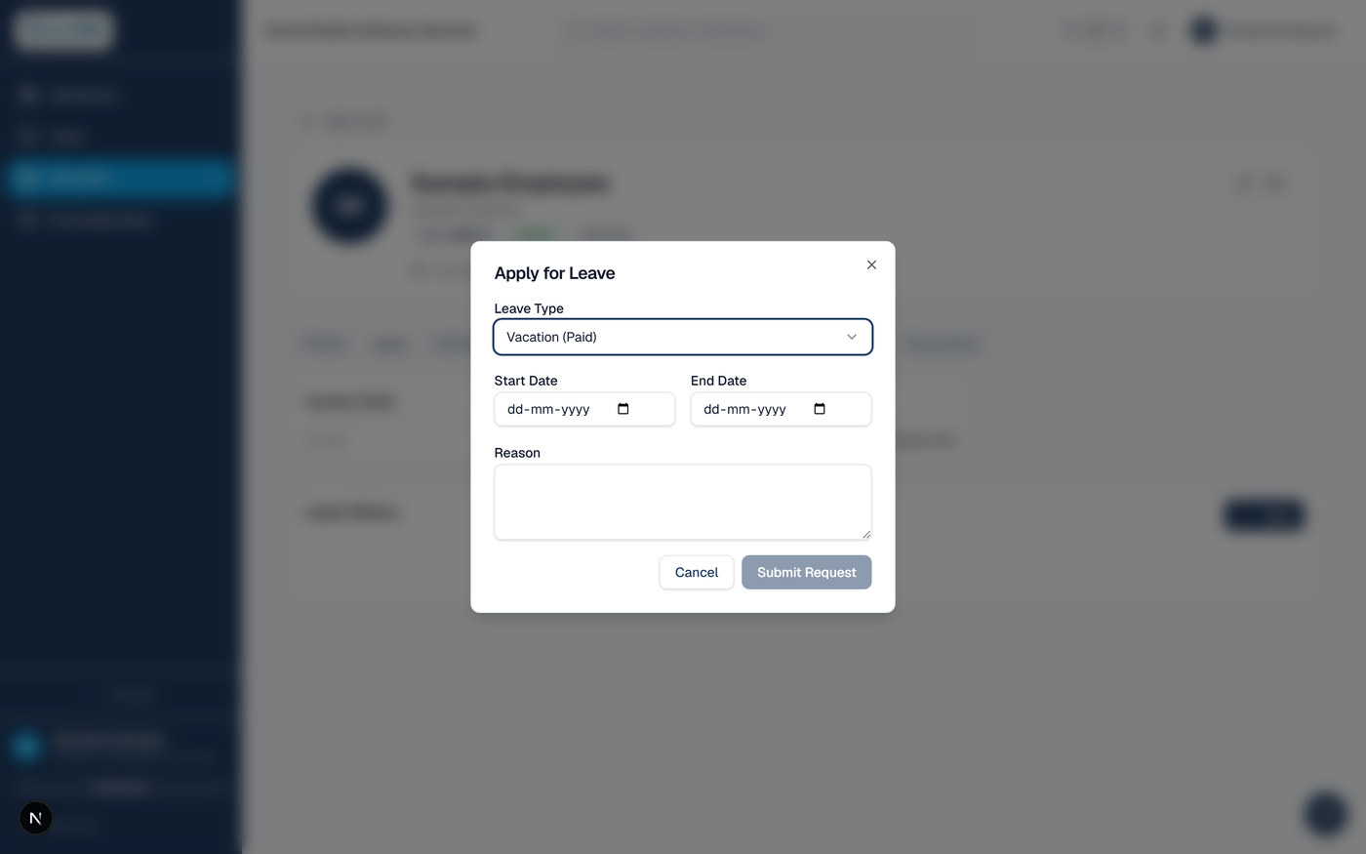
Figure 15 — The Apply for Leave window.
- Choose the Leave Type — for example Vacation (Paid) or Sick Leave.
- Pick your Start Date and End Date.
- Check the number of days the system works out for you. It counts working days only and removes any public holiday in your region.
- Write a short Reason. A line is enough — it helps your manager decide quickly.
- Select Submit Request.
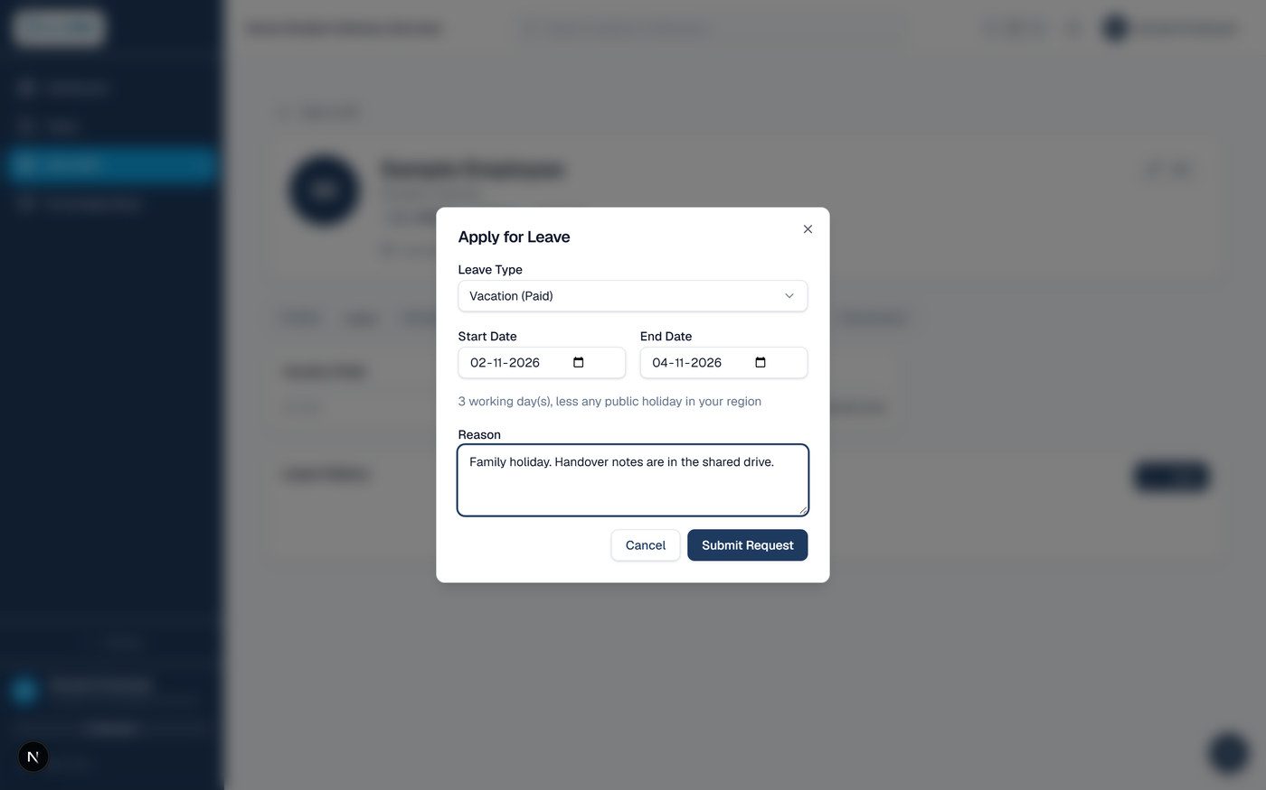
Figure 16 — A completed leave request, ready to submit.
Your request goes straight to your line manager. They receive an email and a notification in the system. You will be emailed as soon as they approve or decline it, and the request will show in your Leave History with its status.
While your request is waiting
The days are held against your balance as soon as you submit, so the figure you see already allows for leave you have asked for but not yet had approved. You cannot book two periods that overlap.

5.3 Public holidays
Open the Holidays tab to see the public holidays that apply to you. HR maintains this calendar. If it is empty, the holidays for your region have not been entered yet — please speak to HR rather than assuming a day is a working day.
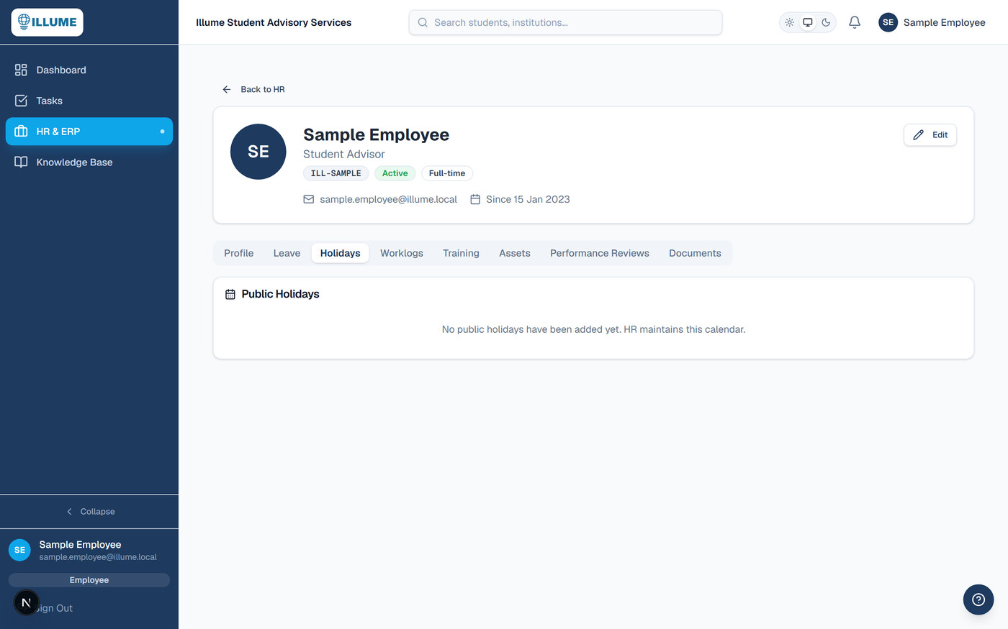
Figure 17 — The Holidays tab.

6. Tasks
Select Tasks in the menu. The panel at the top summarises what is due, what is overdue and what you have finished this week. Your tasks are listed underneath.
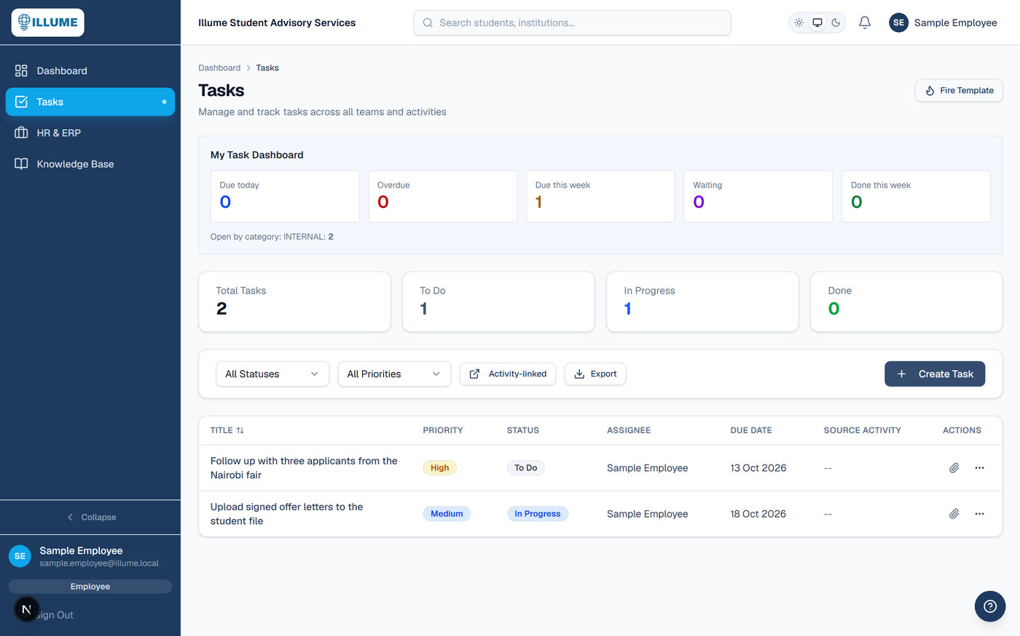
Figure 18 — The Tasks screen.
Who can see your tasks
You see your own tasks, and any task you have assigned to someone who reports to you. Nobody else can see them — not colleagues, not HR, not administrators. Equally, you cannot see a colleague's tasks unless you allocated them yourself.

6.1 Reminders you will receive
You do not need to watch the Tasks screen. Every task with a due date emails you four times:
- When it is assigned to you — immediately, by email and in the system.
- One week before it is due
- Three days before it is due
- On the day it is due
The three reminders arrive together in one message each morning, listing everything that needs you that day — not one email per task.

6.2 Updating a task
Select the status badge on a task to move it between To Do, In Progress, Waiting and Done. Keeping this up to date matters: it is what stops your manager chasing work you have already finished.

6.3 Attaching a file to a task
Each task row has a paperclip in the Actions column on the right. The number beside it tells you how many files are already attached. Select it to open the attachments window, where you can drag a file in or browse for one.
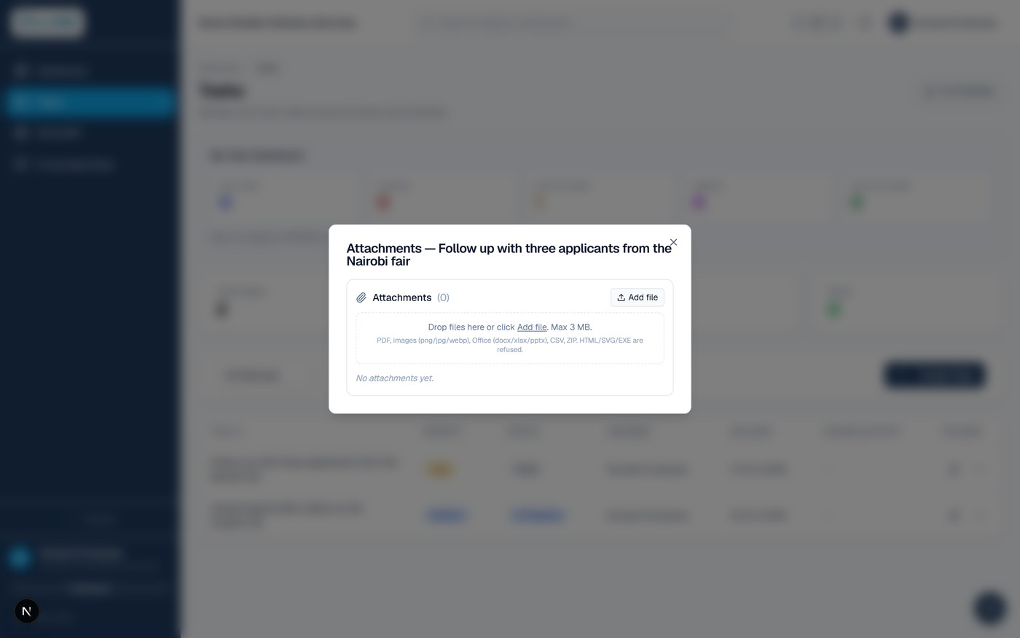
Figure 19 — The attachments window for a task.
- Files can be added by the person who holds the task and the person who assigned it.
- You can always delete a file you uploaded yourself.
- Accepted: PDF, images (PNG, JPG, WEBP), Office files (DOCX, XLSX, PPTX), CSV and ZIP.
- Refused: web pages and program files (HTML, SVG, EXE). This is a safety rule and cannot be overridden.
- Size limit: 3 MB per file. For anything larger, put it in the shared drive and attach a link in the task description.

6.4 Creating a task
Select Create Task at the right of the filter bar.
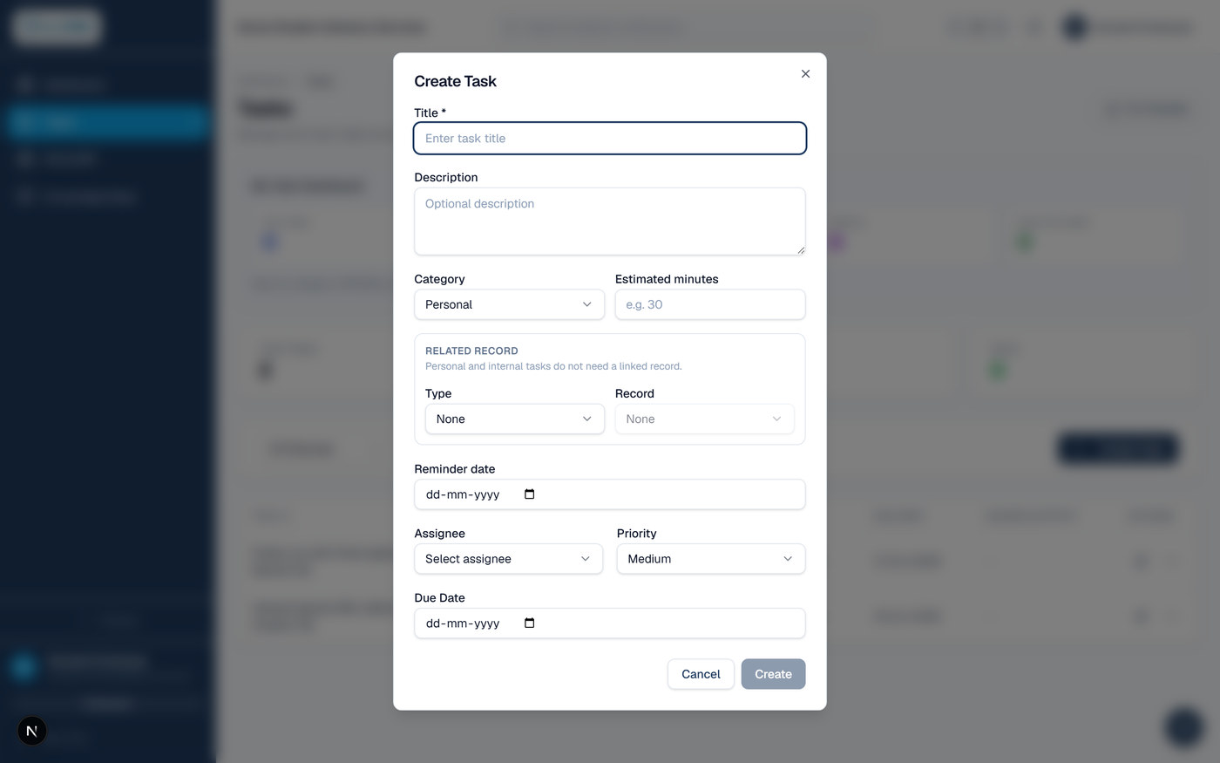
Figure 20 — The Create Task window.
- Title — required. Write what needs doing, not the subject area. “Call the three Nairobi applicants” is useful; “Nairobi” is not.
- Description — optional, but this is where handover detail belongs.
- Category — Personal or Internal if the task stands alone. Any other category needs a linked record, which you choose under Related Record just below.
- Related Record — only if the category requires it. Pick the Type, then the Record. Leave both as None for a personal or internal task.
- Assignee — yourself, or someone who reports to you. See the note below.
- Priority and Due Date — the due date is what drives the reminder emails. A task with no due date sends none.
- Select Create.
If the task will not save
The usual reason is Category. Anything other than Personal or Internal must be attached to a record — a student, an institution, an event. Either pick the record under Related Record, or change the category.

Who you can assign a task to
You can assign a task to yourself, or to someone who reports directly to you. That is the whole list, and it is the same for everyone including administrators. If you need something done by someone outside your team, ask their manager to raise it.

7. If something goes wrong
Problem | What to do
I never received the welcome email. | Check your junk or spam folder first. If it is not there, ask HR to confirm the email address on your record and to send it again.
The link in my email says it has expired. | The link lasts 72 hours. Open the sign-in page, choose “Forgot password”, and a new link will be emailed to you.
Nobody has sent me a password. | That is correct — there is no temporary password. Use the link in the welcome email to create your own.
My 6-digit code is refused. | Wait for your app to show a new code and try again. If it keeps failing, your phone's clock may be wrong — turn on automatic date and time on the phone.
I have lost my phone. | Use one of your backup codes to sign in, then set up the authenticator again on your new phone. If you have no backup codes left, contact IT.
I have lost my phone and my backup codes. | Contact IT. They will verify who you are and reset your two-factor setup. Nobody can do this for you over chat or email alone.
My account is locked. | Accounts lock after several failed attempts. Wait, then try again, or contact IT.
I cannot see a menu item a colleague has. | That is expected. People see only the parts of the system their role needs.
The Holidays tab is empty. | The calendar for your region has not been entered yet. Speak to HR before treating a day as a working day.

Keeping your account safe
- Never share your password, your QR code, your 6-digit codes or your backup codes with anyone — including anyone who says they are from IT.
- Illume will never ask you for a code by phone, email or message.
- Sign out when you finish on a shared or public computer.
- If you think someone else has used your account, tell IT the same day.

Document control
Owner: IT. Review: annually, or whenever the onboarding or sign-in process changes. Questions about this guide, access or passwords should go to IT. Questions about leave entitlement, public holidays or your staff record should go to HR.

